DNR NUTRIENT MANAGEMENT PLAN
NARRATIVE TEMPLATE
May 2013

The purpose of this document is to provide written guidance* to CAFO permitted farms for creating or updating a narrative for a Nutrient Management Plan (NMP). This narrative template is written to help CAFO permitted farms demonstrate compliance with the NMP requirements of NR 243, NRCS 590 and WPDES permit conditions and to streamline NMP development and implementation.
NR 243 plan content requires that all NMPs shall contain information necessary to document how the operation’s land application activities will comply with the restrictions of NRCS 590, NR 243 and the conditions of the operation’s WPDES permit [NR 243.14(1)(b)].
NR 243 contains both general and specific manure and process wastewater land application restrictions. A NMP narrative is an excellent way for a CAFO permitted farm to demonstrate how it will comply with general and specific land application restrictions of NR 243 and some applicable requirements from NRCS 590.
Several narrative areas contain RED text. RED text indicates where a CAFO permitted farm will need to provide or reference farm specific information (manure spreading methods, schedule, etc.). Appendix B and D contain RED text with grey highlight. These are examples showing how form may be used.

*This document is intended solely as guidance, and does not contain any mandatory requirements except where requirements found in statute or administrative rule are referenced. This guidance does not establish or affect legal rights or obligations, and is not finally determinative of any of the issues addressed. This guidance does not create any rights enforceable by any party in litigation with the State of Wisconsin or the Department of Natural Resources. Any regulatory decisions made by the Department of Natural Resources in any matter addressed by this guidance will be made by applying the governing statutes and administrative rules to the relevant facts.

Wisconsin NR 243 Requirements

Farm Sites with Expected Animal Numbers for First Year of Permit and Remaining Permit Term

(Next Four Years)

The following tables provide the current and expected animal numbers that will be included for the first year permit term and the remaining permit term (4 years). Current and projected animal numbers are listed by farm (below) and are consistent with the final A.U. Calculation Worksheet(s) (form 3400-25A). See Section X of plan for this information. Farms included in this NMP are as follows: Main Farm X, Satellite Farm X, etc. Please be advised that future years are an estimate of animal numbers and actual numbers may vary from these values. Actual animal numbers will be revised in the NMP Annual Updates.

Main Farm X Number of Animals
Year | Herd Size (Milk+Dry+1000lbHeifer+600lbHeifer+Calf) | Total Animal Units
2010 | 800 (600+80+50+50+20) | 1041
2011 | 800 (600+80+50+50+20) | 1041
2012 | 1620 (1300+200+50+50+20) | 2189
2013 | 1620 (1300+200+50+50+20) | 2189
2014 | 2070 (1700+250+50+50+20) | 2819

Satellite Farm X Number of Animals
Year | Herd Size  (Milk+Dry+1000lbHeifer+600lbHeifer+Calf) | Total Animal Units
2010 | 500 (0+0+200+200+100) | 360
2011 | 500 (0+0+200+200+100) | 360
2012 | 1100 (0+0+450+450+200) | 805
2013 | 1100 (0+0+450+450+200) | 805
2014 | 1350 (0+0+550+550+250) | 985
Note: Add additional tables for multiple satellite farms.

Total Number of Animals from All Sites
Year | Total Herd Size  (Milk+Dry+1000lbHeifer+600lbHeifer+Calf) | Total Animal Units
2010 | 1300 (600+80+250+250+120) | 1401
2011 | 1300 (600+80+250+250+120) | 1401
2012 | 2720 (1300+200+500+500+220) | 3024
2013 | 2720 (1300+200+500+500+220) | 3024
2014 | 2000 (1700+250+600+600+270) | 3804

Expected Amounts and Types of Manure and Process Wastewater Produced on Annual Basis

All sources and correlating manure generation volumes were calculated using the SnapPlus manure production estimator or the Wisconsin Manure Production Estimation worksheet found in Appendix A of this narrative.

Manure Liquids and Solids Volumes Generated for all Sites and Sources
Year | Total Liquids | Total Solids
2010 | 7,300,000 gallons | 8,513 tons
2011 | 7,300,000 gallons | 8,513 tons
2012 | 15,946,500gallons | 17,070 tons
2013 | 15,946,500 gallons | 17,070 tons
2014 | 20,730,400 gallons | 20,287 tons

Other Nutrient Sources for Land Application (NRCS 590 Requirement)

Other nutrient sources generated, stored or received by this operation include feed storage leachate and runoff, waste feed, solid storage runoff, septic waste, etc. All nutrient sources generated or received by farm have been included in the total manure and process wastewater volume calculations within this NMP. Please refer to the SnapPlus nutrient source and manure production estimator and Section X of plan for calculations of other nutrient sources of waste to be land applied to the fields.

Volumes of Other Nutrient Sources to be Land Applied
Liquid Waste Sources | Volume of Waste Collected | Solid Waste Sources | Total Amount
Feed Storage Leachate | 550,000 gallons | Waste Feed | 20 tons
Solid Storage Runoff | 100,000 gallons
Septic Waste – Joes Hauling | 2,000,000 gallons
Total Liquid Waste Sources | 3,650,000 gallons | Total Solid Waste Sources | 20 tons
Note: Add additional rows for other sources of waste generated or received by the operation.

Amount of manure, process wastewater and other sources to be land applied
Please refer to Section X of plan for calculations/analysis for table value and Section X of plan for land application schedules for specific fields.

Total Amount of Manure, Process Wastewater and Other Sources to be Land Applied
Year | Total Liquids created | Total Liquids applied | Total Solids created | Total Solids applied
2010 | 9,950,000 gallons | 10,500,000 gallons | 8,533 tons | 9,000 tons
2011 | 9,950,000 gallons | 11,000,000 gallons | 8,533 tons | 9,000 tons
2012 | 19,596,000 gallons | 20,600,000 gallons | 17,090 tons | 18,000 tons
2013 | 19,596,500 gallons | 20,600,000 gallons | 17,090 tons | 18,500 tons
2014 | 24,380,000 gallons | 26,000,000 gallons | 20,307 tons | 20,500 tons

Anticipated frequency and method(s) of land application
Farm X anticipates applying manure according to the following schedule: approximately twice per month for 3-4 day periods in May, July, October and November. Spreading will occur in spring before planting and in fall after harvest and after harvests of alfalfa, wheat and other crops. There will be no planned winter spreading. Please refer to Section X of plan for land application schedules for specific fields. Please also refer to Section X of plan for map and field verification procedures that will be followed to verify areas of fields are not prohibited from manure spreading and NR 243 or NRCS 590 setback requirements are followed.

Farm X anticipates using the following equipment to spread liquid and solid manure on fields in NM plan:
Surface manure spreaders or liquid injectors for liquid manure and process wastewater; surface spreaders for all solid manure. In the fall and spring, liquid manure will be either injected as much as possible, or incorporated immediately (SWQMA) or within 48 hours of surface application (non-SWQMA) whichever applies. All liquid or solid manure not injected will be incorporated with a disk till, or in the case of No-Till or alfalfa it will be surface applied in accordance with all NR 243 and NRCS 590 rules. In the summer, liquid manure may be top dressed on some alfalfa fields. Liquid manure spread on X Farm farm is hauled and applied by X Farm or Custom Hauler Name.

Other methods of use, disposal, distribution or treatment of manure or process wastewater
Farm X does not plan any other methods of use, disposal, or distribution of manure or process wastewater.
OR
Farm X does plan to use other methods of use, disposal, or distribution of manure or process wastewater. Those methods are: X, X, X. Please refer to Section X of plan for more information about these methods.

Total acreage available (by landowner) for land application owned, rented or in ‘agreements’.
The table below summarizes this information. Please refer to Section X of plan for more information related to landbase documentation. The farm has a total of approximately X spreadable acres of available after various restricted areas have been accounted for.
Total land application acres available – 825
Acres owned – 600 ; Acres Rented – 100; Acres in agreements – 125
Land Owner Name | Field Name | Acres | Rental or Agreement Length | Length | Shared Land* Y/N | Additional Field Info
Farm X | 1-25 | 600 | Owned land |  | Y | Egcetera wastewater
P. Cracker | 100 | 30 | 3 year | Written | N
J. Doe | 101 | 20 | 3 year | Written | N
P. White | 102, 103 | 8, 42 | 2 year | Written | Y | Smith Dairy also uses field
P. White | 104 | 65 | Annual | Verbal | Y | Jones Dairy also uses field
P. White | 105 | 65 | 2 yr | Verbal | Y | Egcetera wastewater

NOTE: Shared land means fields that receive nutrients from more than one farm or nutrient source (e.g., manure, industrial wastewater, commercial fertilizer, septage, etc). These fields must be carefully tracked within the NMP.

Tillage and crop rotation information for all fields owned or rented or in ‘agreements’
Please refer to Section X of plan for tillage, crop rotation and land application schedules for specific fields.

Nutrient crediting requirements - NR 243.14(3)
When selecting manure and process wastewater application rates for all fields, Farm X has taken into account:
- soil nutrient levels prior to land spreading
- known nutrient applications from other sources, including:
  - commercial fertilizers
  - bio-solids
  - first and second year manure and legume credits
  - other sources of nutrients that are expected to be applied or have already been applied to fields.
Adjustments will be made to assumed nutrient credits based upon actual crop yields.
SWQMA application restriction option for each field AND procedures- NR 243.14(4)
For all fields, except those with alfalfa crop in rotation, Farm X will follow SWQMA option 1 - no application of manure or process wastewater within 25 feet of a navigable water, conduit to navigable water or wetland; and inject or immediately incorporate manure and process wastewater in all other areas within the SWQMA.

For fields with alfalfa crops in rotation, Farm X will follow SWQMA option 5 – No application of manure or process wastewater within 100 feet of navigable water or conduit to navigable water.

Phosphorus delivery method (Soil Test P or P Index) and P management procedures for each field- NR 243.14(5)
Farm X will use the P Index for all fields within the NMP. Please refer to Section X of plan for this information.
OR
Farm X will use a combination of Soil Test P and P Index for all fields within NMP. See table below for field specific method selected by Farm X OR please refer to Section X of plan for this information.

Field | STP | PI | Soil Test  result | Field | STP | PI | Soil Test  result | Field | STP | PI | Soil Test  result
1 |  | x | 112 | 11 |  | x | 178 | K3 |  | x | 178
2 |  | x | 145 | 12 |  | x | 101 | K4 |  | x | 101
3 |  | x | 202 | 13 |  | x | 117 | K5 |  | x | 117
4 | x |  | 12 | 14 |  | x | 122 | K6 | x |  | 22
6 | x |  | 19 | 15 |  | x | 197 | K7 |  | x | 97
7 | x |  | 23 | 17 |  | x | 137 | K8 |  | x | 137
8 | x |  | 15 | K1 | x |  | 15 | K9 | x |  | 15
9 | x |  | 22 | K2 | x |  | 22 | K10 | x |  | 22

Farm X will follow the P Management procedures listed below when applying manure and process wastewater to fields to demonstrate compliance with NR 243.14(5)(b) and applicable NRCS 590 requirements:

Fields with less than 50 ppm:
- N application rates allowed up to the N needs of the following crop or the N removal of the following legume crop.
OR
- Rotational average PI values for each field shall be 6 or lower. PI is calculated using up to 8 year rotation using current Wisconsin P Index calculations. P applications on fields with PI > 6 may be made only if additional P is needed according to UWEX soil fertility recommendations.

Fields with soil test P between 50-100 ppm:
- P application shall not exceed the total crop P removal for crops to be grown over maximum 8 year rotation.
OR
- Rotational average PI values for each field shall be 6 or lower. PI is calculated using up to 8 year rotation using current Wisconsin P Index calculations. P applications on fields with PI > 6 may be made only if additional P is needed according to UWEX soil fertility recommendations.

Fields with soil test P between 100-200 ppm:
- The rotational average P Index value for the crop rotation or for the next 4 year period, whichever time period is less, will be calculated.
- When P Index is > 6, manure application(s) to field are prohibited.
- When P index is < 6, manure applications allowed with P drawdown by 50% cumulative crop removal over a maximum 4 year rotation will be implemented.

Fields with soil test P greater than 200 ppm:
- P applications from manure and process wastewater prohibited, unless approved by DNR.
- The planned average WI P Index value for the crop rotation or for the next 4 year period, whichever time period is less, will be calculated.
- P drawdown by 50% cumulative crop removal over a maximum 4 year rotation will be implemented.

Soil Test P fields
All fields using soil test P will be included within a current conservation plan for Farm X, or use the erosion assessment tools included with the P Index model. Farm X conservation plan meets the NRCS 590 criteria (V.C.2.b) below and addresses all soil erosion consistent with current crops and management or uses the erosion assessment tools included within the WI P Index model.
NRCS 590 Conservation Plan Criteria - (V.C.2.b)
The plan must be developed by and field verified by a conservation planner to document crop management and the conservation practices used to control sheet and rill erosion to tolerable levels (T) and to provide treatment of ephemeral soil erosion.
    - The conservation plan must be signed by the land operator and approved by the county land conservation committee or their representative.
    - A conservation planner must develop conservation plans using the minimum criteria found in the USDA, NRCS National Planning Procedures Handbook and the WI Field Office Technical Guide.
    - In crop fields where ephemeral erosion is an identified problem, a minimum of one of the following runoff reducing practices shall be implemented:
      - Install/maintain contour strips and/or contour buffer strips.
      - Install/maintain filter strips along surface waters and concentrated flow channels that empty into surface waters that are within or adjoin areas where manure will be applied.
      - Maintain > 30% crop residue or vegetative cover on the soil surface after planting
      - Establish fall cover crops.

All fields using soil test P that have a high potential to deliver phosphorus to 303(d) listed waters impaired by nutrients or outstanding and exceptional resource waters, shall be managed by Farm X to ensure:

- soil test P levels shall not increase over a crop rotation unless DNR provides written approval.
- Same fields that have soil test phosphorus below optimum levels, soil test P levels shall not increase over a rotation above the optimum level for the highest demanding phosphorus crop in a rotation.

Field proximity to nutrient impaired or outstanding/ exceptional waters - NR 243.14(5)
Please refer to Section X of plan for maps showing locations of fields in proximity to these types of waters. To complete these maps, Farm X used the following tools:

DNR 2010 proposed impaired waters list:
http://dnr.wi.gov/topic/impairedwaters/documents/attachment_b_final%20proposed%202010%20impaired%20waters%20list.xls
DNR impaired, outstanding or exceptional waters search tool:
http://dnr.wi.gov/water/impairedSearch.aspx .

Identification of sites for winter (frozen or snow covered ground) spreading – NR 243.14(8)
Farm X does not plan to spread manure onto fields during winter (frozen or snow covered ground) conditions.
OR
Farm X plans to spread manure onto fields in NMP during winter (frozen or snow covered ground) conditions.

For compliance with NR 243.14(8) winter spreading sites requirement, fields X-X have been selected for winter application(s) if application(s) of liquid or soild manure become necessary. Fields X-X have been evaluated by Farm X to meet the NR 243 criteria in Tables 4 and 5 for manure and criteria in 214.17(2) and (6) for process wastewater. Farm X has also determined these fields represent the lowest pollutant delivery to waters of the state and have winter acute loss index value of 4 or less using the Wisconsin Phosphorus Index. In addition, Farm X will evaluate these same fields at time of manure application to determine if conditions are suitable for applying manure and complying with the requirements of NR 243.14(8).

Manure Stacking – NR 243.141
All manure stacking sites used by Farm X shall be included in this NMP and must receive DNR review and approval before use. All manure stacking sites shall be selected for compliance with all requirements of NR 243.141. Please refer to Section X of plan for additional manure stacking site(s) information.

Documentation of 180 days storage and methods for maintaining storage - NR 243.14(9) and NR 243.17(3)
Please refer to Section X of plan for manure storage capacity calculations. Please refer to Section X of plan for land application schedules for specific fields – this schedule demonstrates how Farm X will maintain 180 days storage capacity over time.

General Manure and process wastewater application requirements – NR 243.14(2)(b)(1-13)&(c-f)
Farm X will take several actions to ensure all manure and process wastewater is land applied in compliance following general landspreading requirements of NR 243.14:
- No ponding on application site
- During dry weather, no runoff from the application site, nor discharge to waters of the state through subsurface drains
- No causing fecal contamination of water in a well
- Unless rain event is greater than 25 yr/24 hr event and farm complies with NMP and WPDES permit, no runoff from the application site, nor discharge to waters of the state through subsurface drains due to precipitation or snowmelt
- No application on saturated soils
- Maximize use of available nutrients, prevent delivery of manure and process wastewater to waters of the state, and minimize the loss of nutrients and other contaminants to waters of the state to prevent exceedances of groundwater and surface water quality standards and to prevent impairment of wetland functional values
- Retain nutrients in the soil with minimal movement
- No application within 100 feet of direct conduits to groundwater
- No applications within 100 feet of private well and 1000 feet of commercial well
- No application on fields with soils that are 60 inch thick or less over fractured bedrock when ground is frozen or where snow is present.
- No application when snow is actively melting such that water is flowing off a field.

Please refer to Section X of plan for spreading maps that visually describe how the farm will meet many of these general spreading requirements.

To demonstrate compliance with the NR 243.14 general land application requirements above, Farm X will complete, on an ongoing basis, map and field verification procedures (listed below) to ensure spreading maps are accurate (including soil types, slopes and slope lengths), SWQMA or well setback distances are followed and prohibited conditions/features on fields are identified and avoided when spreading manure or process wastewater to NMP fields. The procedures demonstrate how land application activities will be in compliance with NR 243.14 or NRCS 590 restrictions throughout the permit term.

The prohibited conditions/features that Farm X will evaluate for on each field include: ephemeral erosion or concentrated flow channels, saturated soils, intermittent and perennial streams, grassed waterways, wetlands, lakes, drinking wells, areas of field with bedrock or groundwater within 24 inches of field surface, wells and other direct conduits to groundwater - NR 243.14(2)(b)(3),(5),(6), (7-12). These areas have been inventoried and marked on restriction maps (see Section X of plan).

Farm X will maintain written and/or visual records of ongoing field and map verification actions to demonstrate compliance with NR 243.14 requirements. Please refer to Appendix D and section X of plan for this information.

Field and MapVerification Procedures
Prior to spreading manure onto fields, Farm X employee name (include custom hauler name if applicable) will complete the following map and field verification procedures to ensure all manure spreading will be in compliance with NR 243 and 590 criteria:

- Spreading maps will be reviewed by X and X to identify all restricted or prohibited features and setback distances on field
- Fields will be inspected for restricted or prohibited features; any new conditions/features will be identified.
- Once identified, prohibited field features will be avoided and setback distances (as depicted on spreading maps or in NR 243 or NRCS 590) will be measured and followed during manure spreading.
- Spreading maps will be updated with any new prohibited/restricted field features or conditions.
- A log will be kept with the NMP to track the map and field verification procedures listed above. The log will track:
    - date(s) review took place
    - person(s) involved.
    - fields verified
    - any new field features or conditions identified on fields
    - photos or other documentation of field features or conditions reviewed

Avoiding manure or process wastewater field runoff or ponding– NR 243.14(2)(b)(1), (2)&(6).
Please refer to field and map verification procedures and NRCS 590 requirements for runoff and ponding.

Surface applications & precipitation forecast for runoff within 24 hours – NR 243.14(2)(b)(13)
For this NMP, surface applications of manure will not be completed when rain events above X inches are forecasted within 24 hours of the time of planned applications. Surface application means manure that is applied and left on the surface of the field. Surface application does not mean manure that is surface applied and then incorporated into the soil.
Prior to manure applications to fields, www.accuweather.com will be used to track weather forecast data. This information will be used determine the risk for forecasted precipitation to cause run-off from fields. Weather forecast data will be printed or saved to disc and kept with the NMP. All weather forecast data will be submitted with annual reports as an attachment.

Drain tile fields & tile discharges to surface waters -NR 243.14(2)(b)(2),(4)&(6) and NRCS 590 (V.A.1.k)
Drain tile discharges of manure and process wastewater from fields to surface waters under are not allowed under NR 243. The following fields have been identified to have drain tiles: X-X. Please see section X of plan for additional drain tile field information. Drain tile discharges of manure and process wastewater to surface waters will be prevented or responded to by Farm X via the following procedures:
Prior to spreading manure onto fields with drain tiles:
- UW extension Guidelines for Preferential Flow of Manure in Tile Drainage will be reviewed by Farm X:
http://www.extension.org/pages/Preferential_Flow_of_Manure_in_Tile_Drainage

- The following UW Discovery Farms Drain Tiles documents will be reviewed by Farm X:
- Maintaining Tile Drainage Systems
- Understanding and Locating Drain Tiles
- And any other tile drainage fact sheets currently available on the UW Discovery Farms site at
http://www.uwdiscoveryfarms.org/OurResearch/AgriculturalTileDrainage.aspx
- Spreading maps will be reviewed to identify know drain tile locations
- Fields will be inspected for drain tile presence or outlets; any new tile outlets/subsurface drainage systems will be identified
- All tile outlets will be visually checked for flow and water conditions (e.g., clear, colored, foam, odor, etc).
- Results of all visual tile monitoring will be tracked – using form in Appendix B - and kept with NMP
- Planned manure spreading (rates and locations) on fields will be evaluated and then limited or adjusted, as necessary, according to the following criteria:
- Available water holding capacity of the soil
- Depth of injection
- Clay soil considerations
- Concentration of Application from spreading equipment type used
- Are known tile drains flowing?
- Shallow tillage (3 to 5 inch depth) used or not used prior to application to disrupt the continuity of worm holes, macropores and root channels (preferential pathways) to reduce the risk of manure reaching drain lines.
- Perennial Crop and No Till precautions
During and after manure spreading on fields with drain tiles, best management practices will be followed:
- Visual inspection of tile outlets for flow and water conditions (e.g., clear, colored, foam, odor, etc.)
- Containing manure or process wastewater tile discharges from release into waterway(s)
- Notifying DNR of any spills/discharges to waterways from tiles
- Reducing application rates or delaying application(s) to tiled fields
- Setbacks from tiled areas
- Immediate tillage/ incorporation of applied manure
- Use of other manure application equipment (e.g., sweeps)
- Update NMP spreading maps or narrative
- Results of visual inspections of tiles will be tracked – using form in Appendix B of this narrative and kept with NMP.
Please also refer to NRCS 590 requirements for field runoff, ponding and drainage to subsurface tiles.

Manure applications to areas of fields with shallow groundwater or bedrock – NR 243.14(2)(b)(7).
NR 243 prohibits manure applications on areas of fields that have groundwater or bedrock within 24 inches of the field surface at time of application. Farm X will demonstrate compliance with this prohibition by:
- Implementing DNR guidance, dated March 2009. Please refer to Appendix C of this narrative for the DNR guidance.
OR
- Implementing alternative to DNR guidance. Please refer to section X of plan this information.

Daily Spreading Log and Annual Reports for DNR – NR 243.19
Farm X will maintain daily spreading log for all manure or process wastewater applications to NMP fields for compliance with NR 243.19. The daily spreading log will also be used to complete required annual reports for DNR. Farm X recognizes the daily spreading log and annual reports are essential to document actual management practices used by Farm X and the resulting soil erosion and water quality impacts on specific fields. Farm X will use DNR Forms 3200-123 and 3200-123A (MS excel spreadsheets) to complete Daily spreading and annual reports. These forms will be obtained from DNR. Please refer to section X of plan for this information.

Please also refer to NRCS 590 requirements for Annual Updates to NMP

Manure spreading equipment calibration and Manure concentration testing – NR 243.19
Farm X employee name (include custom hauler name if applicable) shall conduct or require periodic inspections and ongoing calibration of landspreading equipment to detect leaks and ensure accurate application rates for manure and process wastewater. Initial calibrations shall be followed by additional calibration after any equipment modification or after changes in manure or process wastewater consistency and/or source. At a minimum, calibration of all manure spreading equipment used by Farm X shall be completed annually and recorded. Farm X will follow UW extension web page guidance for Calibration of Manure Application Equipment: http://www.extension.org/pages/Calibration_of_Manure_Application_Equipment
Please refer to section X of plan for manure spreading equipment calibration records.

Farm X employee name (include custom hauler name if applicable) shall analyze all manure and process wastewater sources applied to fields in accordance with WPDES permit conditions. Samples shall be collected so they are representative of all manure or process wastewater sources applied to fields. All manure and process wastewater sources shall be analyzed for Nitrogen, Phosphorus, and percent solids in years where manure and process wastewater is applied. Farm X will follow sampling methods found in UW publication A3769, Recommended Methods of Manure Analysis: http://learningstore.uwex.edu/Assets/pdfs/A3769.pdf . Please refer to section X of plan for manure and process wastewater sampling records and related information.

Wisconsin NRCS 590 Requirements
Dominant Critical Soil
Each field in this NMP is managed to meet NRCS dominant critical soil criteria http://datcp.wi.gov/uploads/Farms/pdf/ChoosingCriticalSoilType.pdf. The dominant critical soil is the most erosive soil that covers at least 10% of the field area. The dominant critical soil type was selected for all fields listed in the NMP to ensure corresponding rotational T – tolerable soil loss - values for each field are accurate for compliance with NRCS 590 requirements. Please refer to Section X of plan for this information.

T – Tolerable soil loss
Each field in this NMP is managed to meet T – tolerable soil loss - over the crop rotation. T values were calculated using NRCS RUSLE 2 model. No nutrient applications (manure, fertilizer) are allowed on fields that fail to meet T. Erosion controls shall be implemented so that tolerable soil loss (T) over crop rotation will not be exceeded on fields that receive nutrients. Please refer to Section X of plan for information showing each field’s tolerable and actual soil loss.

Soil Testing
Each field in the NMP is managed for compliance with NRCS A2100 soil testing criteria: http://datcp.wi.gov/uploads/Farms/pdf/uwex-a2100.pdf. Accordingly, all fields in this NMP either meet or are managed to meet A2100 criteria over time. Please refer to Section X of plan for this information. For fields in this NMP that do not currently meet A2100, one of the following management options will be implemented by farm X until soil testing can be completed:
- Manure will not be applied to field;
- Field will be managed as if P levels are greater than 100 ppm P according to NR 243.14(5) criteria for all manure applications to field.

Application and budgeting of nutrients – consistent with NRCS 590 standard and soil fertility recommendations found in A2809.
Each field in the NMP is managed to address the source, rate, timing, form and method of application and budgeting of all nutrient sources (i.e., including soil reserves, commercial fertilizer, manure, organic byproducts –animal mortality and composting materials - legume crops and crop residues) generated or accepted by the farm and applied to fields. Please refer to Section X and X of plan for this information.

Other sources of nutrients to be land applied (NRCS 590 requirement)
Please refer to Section X of plan for calculations/analysis for table values and Section X of plan for specific fields land application amounts and schedules (e.g., spring, summer or fall).
Year | Total Liquid Manure | Total Liquid Wastewater | Total Commercial Fertilzer | Total Animal or Compost Nutrients
2010 | 6,500,000 gallons | 6,800,000 gallons | 350 tons | 380 tons
2011 | 6,500,000 gallons | 7,100,000 gallons | 350 tons | 390 tons
2012 | 13,700,000 gallons | 14,300,000 gallons | 845 tons | 950 tons
2013 | 13,700,000 gallons | 14,400,000 gallons | 845 tons | 990tons
2014 | 17,200,000 gallons | 18,100,000 gallons | 1130 tons | 1270 tons

Crop Yield Goals
Each field in the NMP is managed according to yield goals that are attainable by the farm under average growing conditions and established using multi year documented yields kept by the farm. Farm yield goals in this NMP shall not be set higher than 15% above the previous 3-5 year average. Absent field/farm specific yield goals data, yield goals in this NM plan will be set using Wisconsin county average crop yields found at National Agricultural Statistics Service: http://www.nass.usda.gov/Data_and_Statistics/index.asp Please refer to Section X and X of plan for this information.

Records of soil and manure testing results
Farm X has completed and retained records showing recent soil testing and manure testing results. Please refer to Section X of plan for this information. Farm X acknowledges that soil testing of some fields or manure analyses is out of date and needs to be completed. Farm X will follow the following schedule to ensure manure analysis or soil testing for fields will be completed and then the NMP will be updated with this information.

Schedule for soil testing or manure analysis and then NMP update: X month, year.
Fields with concentrated flow channels resulting in reoccurring gullies or ephemeral erosion
Farm X will evaluate fields on an ongoing basis each year for presence or flow channels or other types of ephemeral soil erosion. If fields show evidence of concentrated flow channels resulting in re-occurring gullies or ephemeral erosion, the following actions will be taken by the farm:
  - Spreading maps will be updated to reflect areas with concentrated flow channels;
  - Manure will not be spread on fields with concentrated flow channels, until perennial vegetative cover is established in all areas of concentrated flow;
  - A schedule for establishing perennial vegetative cover in all areas of concentrated flow as well as implementation dates will be recorded and kept with this NMP.
  - One or more NRCS 590 runoff reducing practices for crop fields with ephemeral erosion will be selected and implemented. Practices selected and implementation dates will be recorded and kept with this NMP.

Once vegetated flow channels/grassed waterways established within fields, such areas will be maintained to perform their intended function and manure will not be applied within these areas.
Schedule for stabilizing soil erosion areas with perennial vegetative cover: X month, year.
Fields with high potential for N leaching to groundwater - soil temperature, application rate and timing restrictions
Fields in this NMP have been evaluated for soils with high potential for N leaching to groundwater for compliance with NRCS 590 requirements. Please refer to Section X and X of plan for this information. When manure is applied fields with soils classified as having a high potential for N leaching to groundwater and the soils are > 50 degrees F, the potential exists for rapid N mineralization. The risk for N mineralization and loss (via leaching to groundwater) is a concern the farm will manage for. As such, Farm X will measure soil temperatures prior to field applications in late summer or fall. Soil temperature logs will be kept with manure spreading records/reports and maintained over time for compliance recordkeeping requirements. The farm will follow the following procedures for compliance with NRCS 590 soil temperature, application rate and timing restrictions:
- If any fields are found to be > 50 degrees F, Farm X will strictly follow section V, B, 2 of NRCS 590 standard.
- If any fields are found to be < 50 degrees F, Farm X will strictly follow section V, B, 3 of NRCS 590 standard.

Field Inspection and Response Procedures for manure ponding, runoff from fields or drainage to subsurface tiles.
Farm X will evaluate field and weather conditions prior to and during mechanical applications of manures, organic byproducts and fertilizer to ensure that applied material(s) do not cause ponding, runoff, or drainage to subsurface tiles.
The following response procedures will be followed by Farm X if/when ponding, runoff or drainage to subsurface tiles occurs during and/or after applications to fields:
- Stop application immediately (if field application not finished)
- Containment measures (e.g., earth berms, pumps, temporary pits, tillage, incorporation) will be implemented immediately to prevent off-site movement from field.
- Changes in application rate, method, depth of injection or timing to the field shall be implemented during any future application to eliminate ponding, runoff or drainage to subsurface tiles.
- Farm shall notify DNR of any spills or accidental release to comply with Ag Spill Law (289.11) or term of WPDES permit.

Annual Updates
This NMP will be updated annually. Each NMP annual update for Farm X shall include records/documentation of all soil or manure analyses as well as crops, tillage, nutrient application rates, and methods actually implemented on each field that receives nutrients. Annual updates are essential to document actual management practices and resulting soil erosion and water quality impacts on specific fields.

Provide following info for Reissuance permit:
- Changes to the operation that have or are planned to occur during upcoming permit term

- Changes to the operation that will be necessary to comply with NR 243.14 Nutrient Management land application requirements (e.g., general requirements – 243.14.(2)(b)1-13, fields with drain tiles, 180 days storage).

- Location of existing site and proposed modifications to the site

- Description of permanent spray irrigation systems AND any other landspreading or treatment systems
- Include all 1st time WPDES permit issuance criteria listed above here

Appendix A
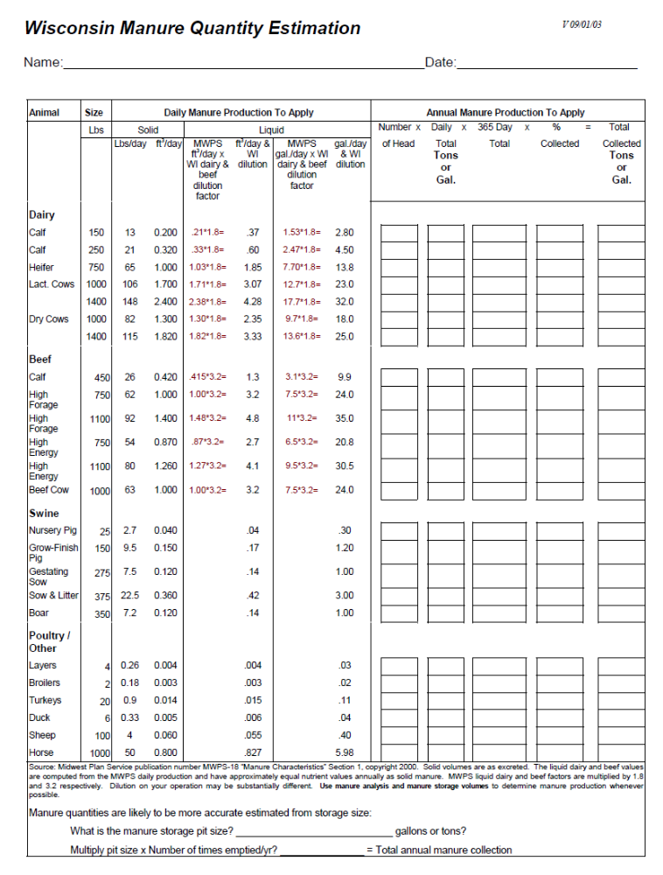
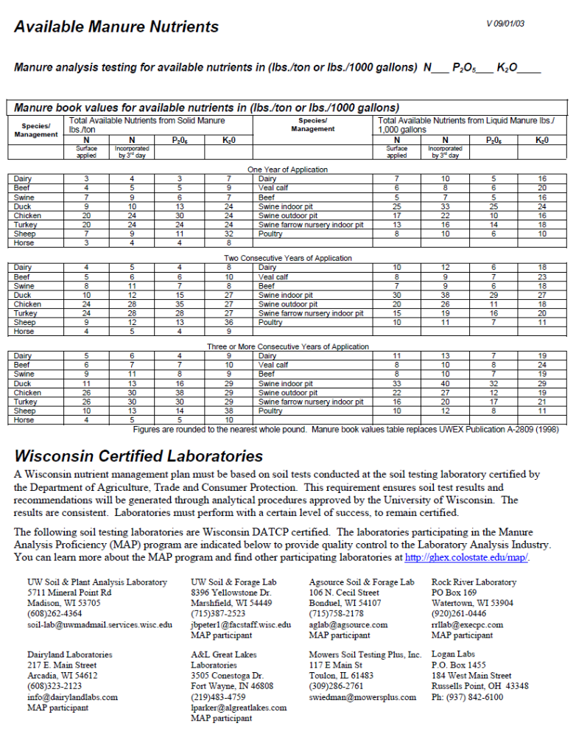

Appendix B
Drain Tile Inspection Log
 |  |  |  | Outlet flow before manure application |  |  |  |  |  |  |  | Outlet flow during/after manure application
Date | Field Name | Acres | Tile Out-let ID | Flow?  Check Time? | Describe flow, rate, color, odor | Manure Source | Manure spread method | Start & End Time for Appli-cation | Amt. Per acre | Soil Conditions | Weather Conditions | Flow?  Check Time? | Describe flow, rate, color, odor | ResponseActions Taken?
6/5/2009 | R1 | 12 | 1 | Yes  10AM | Clear, no odor, trickle | 001 | IJ | 1030- 11AM | 5,000 gal/acre | Moist, but no ponding | C, W | Yes  11 AM | Brown, foamy, more flow than before | Yes – see next page
6/6/2009 | R2 | 23 | 1, 2 | Yes  3PM | Clear, no odor | 001 | IC | 330PM 630PM | 7,000 gal/acre | Dry – some cracks | S | Yes  400 PM 645 PM | Clear during – all check and each outlet | No
Nutrient Sources Soil Conditions Application Method Weather
001 = Pit 1 Liquid D = Dry SN=Snow Covered SA = Surface Applied S = Sunny LR = Light Rain 002 = Separated Solids W = Wet IJ = Injected C = Cloudy HR = Heavy Rain
003 = Bunker Waste FZ = Frozen IC = Incorporated W = Windy SN = Snow
Actions Taken in Response to Tile Discharges

Date | Actions Taken
06/05/2009 | Stopped application immediately (11AM) after seeing brown water leaving tile outlet 1. Installed containment berm, per NMP, 50 feet downstream tile 1 outlet. Pumped contaminated ditch water onto adjacent field. Reported spill to DNR spills hotline and DNR inspector X after stopping spill.

Appendix C

 BUREAU OF WATERSHED MANAGEMENT
INTERIM GUIDANCE
NUTRIENT MANAGEMENT - CAFO APPLICATIONS ON SHALLOW GROUNDWATER SOILS
March 2009
Description: Ch. NR 243, Wis. Adm. Code, restrictions CAFO manure and process wastewater applications to fields that have less than 24 inches of soil over groundwater or bedrock.

This guidance describes how permittees and their consultants can identify and determine whether to use these fields as well as how Department staff can review fields for compliance with this requirement.

This document is intended solely as guidance, and does not contain any mandatory requirements except where requirements found in statute or administrative rule are referenced. This guidance does not establish or affect legal rights or obligations, and is not finally determinative of any of the issues addressed. This guidance does not create any rights enforceable by any party in litigation with the State of Wisconsin or the Department of Natural Resources. Any regulatory decisions made by the Department of Natural Resources in any matter addressed by this guidance will be made by applying the governing statutes and administrative rules to the relevant facts.

Background
NR 243.14(2)(b)(7) requires CAFO manure or process wastewater applications may not be applied on areas of a field with a depth to groundwater or bedrock of less than 24 inches.
This restriction applies only to those portions of field that have less than 24 inches of separation to groundwater. If portions of a field have at least 24” of soil, these portions of the field are not subject to the prohibition (i.e., there is no deminimus amount of field that falls into/out of a prohibition area that would allow the entire field to be determined to not meet/meet the restriction).
NRCS Conservation Planning Technical Note WI-l
This document (Appendix 1) identifies soils with high potential for groundwater contamination. It places restrictions on ‘w’ type soils. The ‘w’ symbol indicates the soil is very poorly and poorly drained has an apparent water table that is less than 12 inches from the surface for any duration at any time of the year. Accordingly, ‘w’ soils indicate, by definition, where the depth to groundwater may also be within 24 inches of the field surface for any duration at any time of the year.
Tech Note WI-1 link (Sept 2007):http://www.wi.nrcs.usda.gov/technical/technotes.html
NRCS Soil Description for ‘w’ soils
NRCS soil descriptions provide more detailed information for individual soils, including ‘w’ soils. Each description contains a category entitled DRAINAGE AND SATURATED HYDRAULIC CONDUCTIVITY. This category describes the depth to water table (groundwater) for specific time periods. Here are two examples:
Example 1 - Poorly drained. An apparent seasonal high water table is at 15 cm (0.5 foot) above the surface to 31 cm (1.0 foot) below the surface at some time during spring in most years.
Example 2 - Very poorly drained. Depth to the seasonal high water table ranges from 2 foot above the surface in ponded phases to 1 foot below the surface from September to June.
For specific NRCS soil descriptions, use NRCS Soil Description Search link (click on soil series name search): http://soils.usda.gov/technical/classification/osd/index.html
NRCS soil description, groundwater depth factors and NR 243 compliance
The NRCS soil descriptions, however, are not regulatory. They are general guidance provided by NRCS for general nutrient management purposes. The actual depth to groundwater on a specific day or under specific conditions may vary from the NRCS narrative soil descriptions.
The following factors influence groundwater depth:
- Soil type(s) and moisture content.
- Field topography.
- Weather patterns (wet or dry seasons).
- Drainage systems (ditches and drain tiles).
- Crop and Tillage types.

NR 243.14 requires manure applications to fields meet the depth to groundwater requirement on a field by field basis at the time of application. The steps described below provide permitted CAFO farms some methods to demonstrate compliance with the NR243 depth to groundwater requirement. Please note, this guidance does not preclude a CAFO farm from submitting or implementing alternative methods to this guidance*.
* = Alternative methods do not become effective until the department has reviewed and approved the method.

Interim guidance for shallow groundwater soils
- For each field listed in farm’s Nutrient Management Plan (NMP), identify and map all ‘w’ soil units using tools below. Keep with NMP.
Web Soil Survey - http://websoilsurvey.nrcs.usda.gov/app/
Tech Note WI-1 (Appx 1)- http://www.wi.nrcs.usda.gov/technical/technotes.html
- For each field, document the NRCS Soil Series description for all ‘w’ soil units using link below. Keep with NMP. Use DRAINAGE AND SATURATED HYDRAULIC CONDUCTIVITY description to determine depth to water table time period(s).
NRCS Soil Description - http://soils.usda.gov/technical/classification/osd/index.html
- If possible, avoid applying manure or process wastewater to areas of fields with ‘w’ soils during shallow groundwater time periods listed in NRCS soil description(s). If avoidance is not possible, follow steps 4-6 below.

- Before any application, inspect the ‘w’ soil section(s) of the field and answer the following question: Are ‘w’ soil sections of field ‘idle’ - Y or N?
For purposes of this guidance, “idle” means: the ‘w’ soil section(s) of field show evidence of hydric soils and exhibit: (1) Wetland vegetation (woody vegetation, shrubs, grasses) or (2) Abandoned condition (e.g., no crops or evidence of recent crops for at least two years).
    - If Y – no application; locate alternative acreage.
    - If N – go to Step 5.

- Before any application, demonstrate ‘w’ soil sections of field do not have a groundwater depth of less than 24 inches.
    - If Y– apply manure and follow all other NR243.14 manure spreading requirements.
    - If N– no application; locate alternative acreage; or apply at time when groundwater depth is greater than 24 inches.

For purposes of this guidance, ‘demonstrate’ means one of the following options:
- Locate drain tile(s) on the field with ‘w’ soils units. Determine drain tile(s) are functioning and tile depth is 24 inches or greater from the surface of the field. If drain tile(s) meet criteria above, complete application and follow all other NR243 spreading requirements (e.g., preventing drain tile discharges to surface waters).

- Excavate at least two “representative” soil pits within at least one ‘w’ soil area on the field that is five acres or less in size* (using mechanical soil auger or manual hand tools) to a depth of at least 30 inches. After at least one hour, observe if the water table is below 24 inches of surface. If both pits (for each five acre area) meet the criteria above, refill each pit, complete application and follow all other NR243 spreading requirements.

*= When ‘w’ soil area on field is greater than five acres in size, excavate additional soil pits so a ratio of two pits for each 5 acre sized ‘w’ soil unit is met.
For purposes of this guidance, “representative” means choosing locations within a ‘w’ soil area of field that reflects the overall structure and characteristics of the ‘w’ soil unit.
(6) Document steps taken at each field with ‘w’ soil units in WPDES permit daily and annual spreading reports.

Appendix D: Field and Map Verification Log

Date | Field Name | Person | Existing Field or Map Feature(s) checked? | Photos? ID # | New Field Features Identified? | Action(s) Taken?
3/19/2010 | 1 | Jeff White | Field SWQMA; wetland | Yes - 1201 | Yes- flow channels in SE corner of field | Establish grass seed in waterways; update spread maps with new channels
3/20/2010 | 12 | Jeff White | Field - W soils | Yes - 1202 | No | No groundwater at 24 inches
3/25/2010 | All Fields | Jeff White & Mike’s Manure Hauling | Maps - All spread maps reviewed with custom hauler | No |  | Reviewed setback distances and manure inject or incorporation requirements on all fields

